2. Why Naples Continues to Attract Luxury Buyers From Around the World

SEO Title
Why Luxury Buyers Are Moving to Naples Florida

Meta Description
Discover why Naples continues attracting luxury homebuyers seeking waterfront living, tax advantages, golf, boating, and a world-class coastal lifestyle.

Target Keywords
moving to Naples Florida, Naples luxury lifestyle, Naples waterfront real estate, luxury homes Naples FL, Naples relocation guide

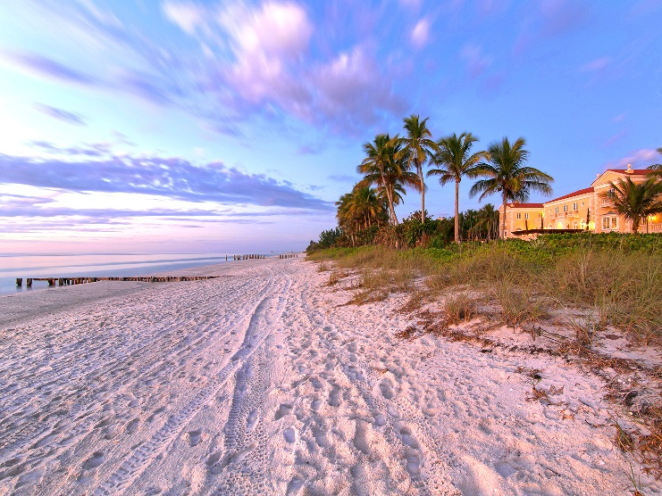

Suggested CTA
Thinking about relocating to Naples? Contact Michael Giacalone at Premier Sotheby’s International Realty for private market insights and available listings. 239.431.0321

More Than Sunshine and Beaches
Naples has long been known for its beautiful coastline and relaxed coastal lifestyle, but today it is attracting an entirely new wave of luxury buyers. From entrepreneurs and executives to retirees and second-home owners, people are relocating to Naples for far more than warm weather.
One major factor is quality of life. Naples offers a rare combination of luxury amenities and a slower pace of living. Residents can enjoy world-class golf courses, upscale shopping, award-winning dining, boating, fishing, and cultural attractions—all within a highly walkable and beautifully maintained environment.
Another reason buyers continue to invest in Naples real estate is stability. Luxury waterfront properties in communities like Port Royal, Aqualane Shores, and Old Naples have consistently remained highly desirable. Limited inventory combined with strong demand has helped support long-term value.
Buyers are also increasingly drawn to Naples because of Florida’s favorable tax environment and the ability to work remotely while maintaining an exceptional lifestyle. Many families who initially purchased seasonal homes are now transitioning into full-time residents.
Beyond the luxury market itself, Naples offers something many high-end buyers are searching for today: simplicity. The ability to spend mornings on the water, afternoons on the golf course, and evenings enjoying sunset dinners downtown creates a lifestyle that feels effortless.
For those exploring Southwest Florida real estate opportunities, Naples continues to stand apart as one of the country’s premier coastal destinations.

